HW1 for Multivariate Statistics(I)
Chapter 1. Multivariate Data Analysis

Class : Multivariate Statistics(I) (ST27517-032)
Major : 전기공학과
Student ID : 201724570
Student Name : 정석규

Consider the Economicview data (economicview.txt) which is given in [Data 1.3.5].

(1) Find mean vector, covariance matrix S and Correlation matrix R

Code)
# Library and Datasets
library(dslabs)
library(tidyr)
library(MVN)

ev_dataset <- read.table("Multivariate_Statistics/economicview.txt", encoding = "EUC-KR", header = T)

# View datasets
str(ev_dataset)
X = ev_dataset[, -1]

# Q1. Find mean vector, covariance matrix S and Correlation matrix R

# mean vector
mean_vector <- colMeans(X)
mean_vector

# covariance matrix S
matrix_S <- cov(X)
matrix_S

# Correlation matrix R
matrix_R <- co

Result)

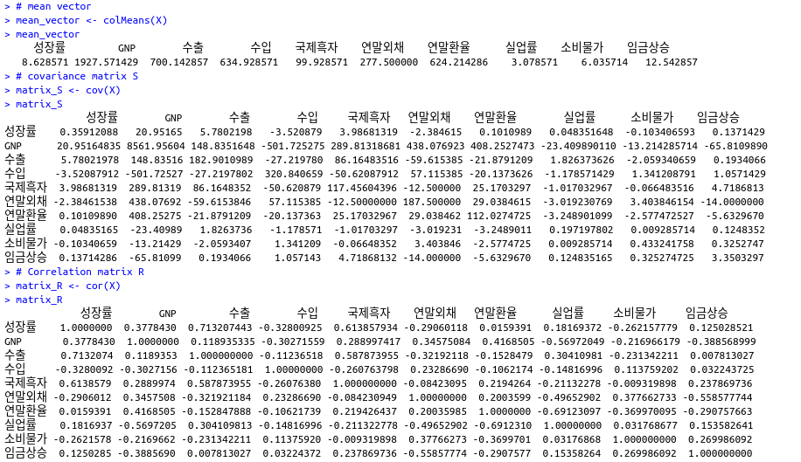

(2) Apply methods used in [R-code 1.3.1] and [R-code 1.3.2] and Explain their results.

Code)
# Q2. Apply methods used in [R-code 1.3.1] and [R-code 1.3.2] and Explain their results

# R-code 1.3.2
summary(X)
cov(X)
cor(X)
plot(X)
boxplot(X)

Result)

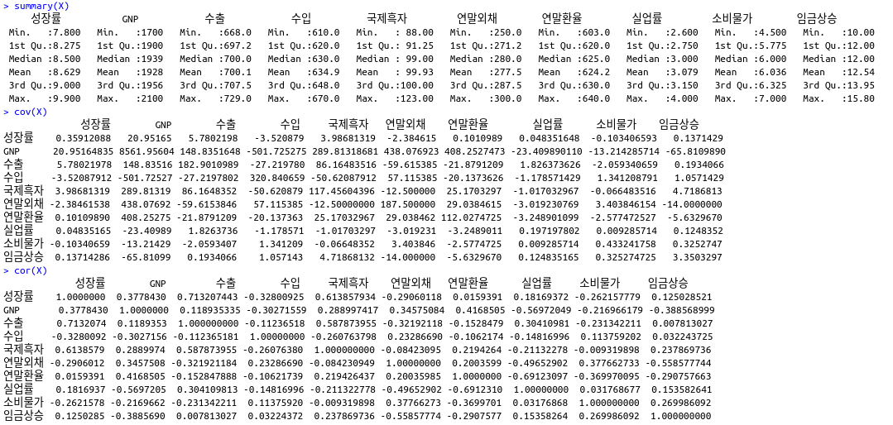
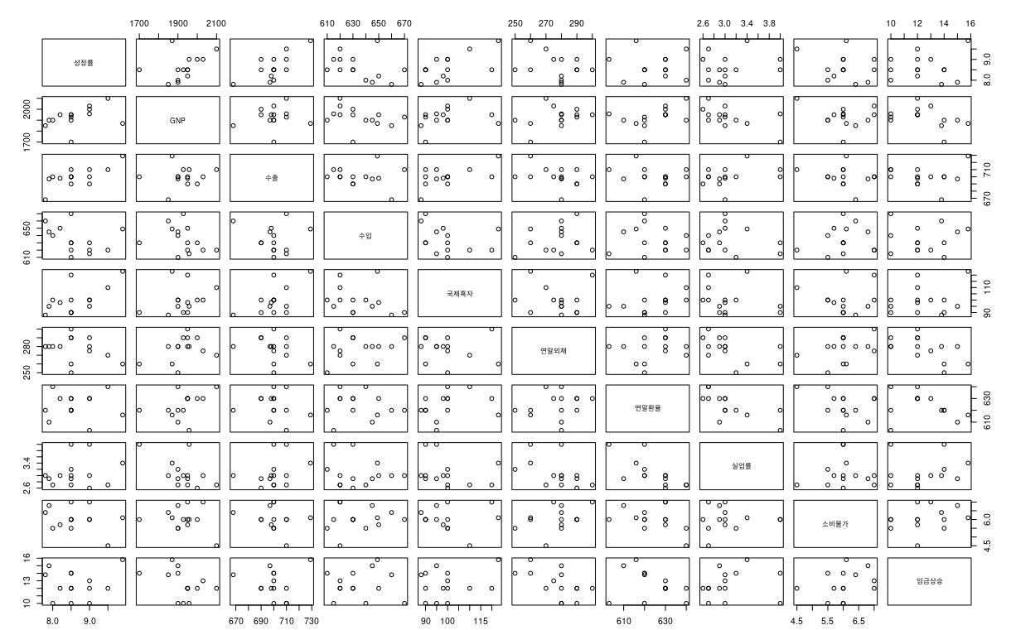
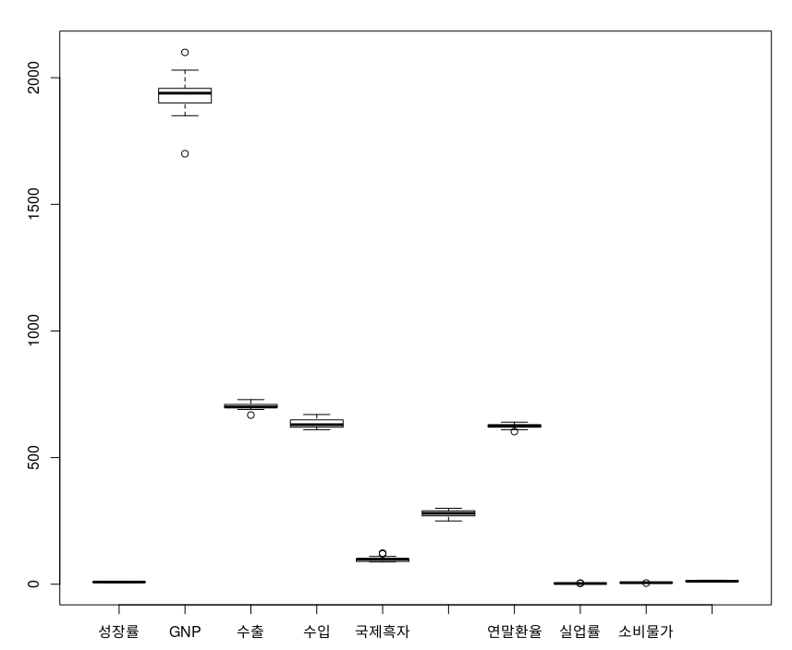

(3) Between centering & standardizing, which one is more appropriate for the data ?

Code)
# Q3. Between centering & standardizing, which one is more appropriate for the data?

# centering

centering_matrix <- scale(X, scale = F)
centering_matrix

# standardizing

standardizing_matrix <- scale(X, scale = T)
standardizing_matrix

Result)

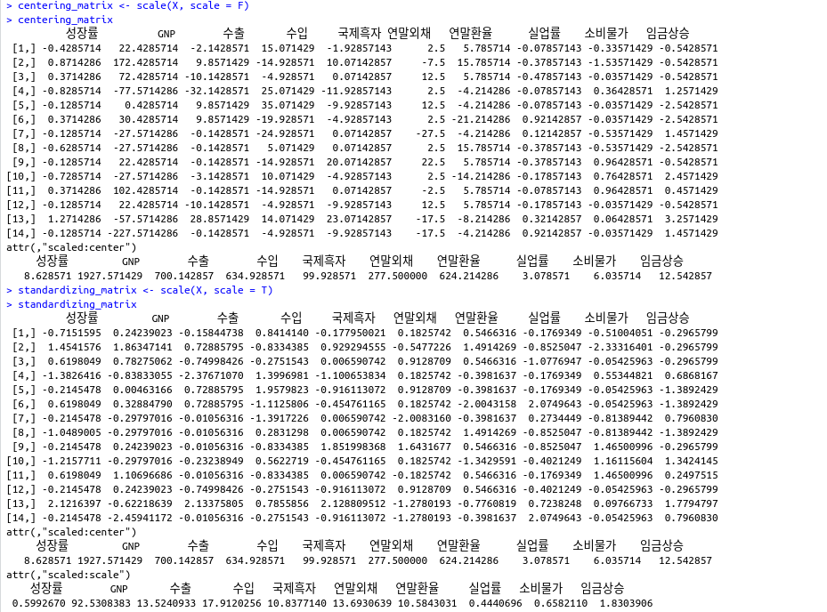
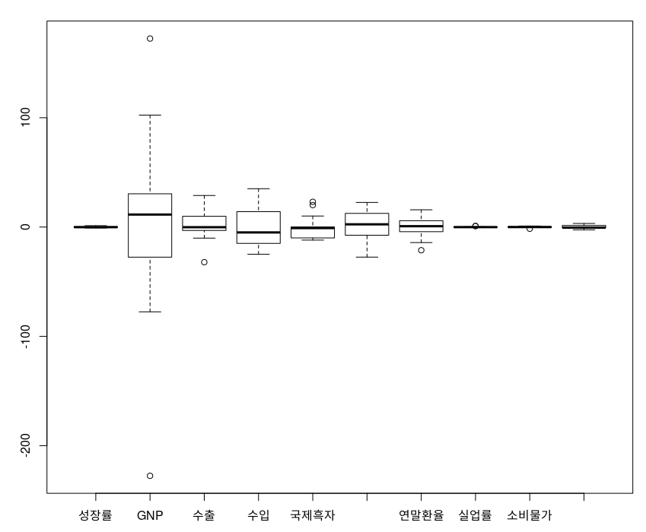

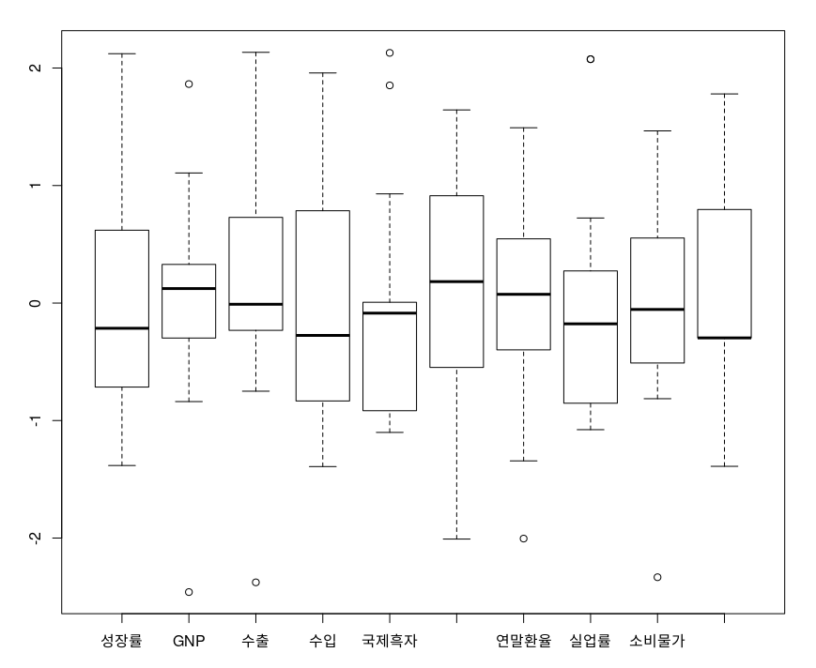

(4) Check the multivariate normality based on Chi-squared plot and Mardia’s test.

Code)
# Q4. Check the multivariate normality based on Chi-square plot and Mardia's test.

# Chi-square
x = ev_dataset[, -1]
n = dim(x)[[1]]
p = dim(x)[[2]]
S = cov(x)
xbar = colMeans(x)
m = mahalanobis(x, xbar, S)
m = sort(m)
id = seq(1, n)
pt = (id-0.5)/n
q = qchisq(pt, p)
plot(q, m, pch = "*", xlab = "Quantile", ylab = "Ordered Squared Distance")
abline(0, 1)

# MVN test
result = mvn(x, mvnTest = "mardia", multivariatePlot = "qq")
result

Result)

